A000-AFR-EGY-Pharoahs-Upper and Lower Egypt-Basalt-1500-500 BCE

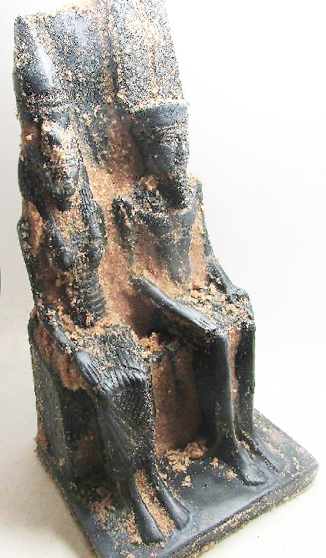

Fig. 1. Pharoahs-Upper and Lower Egypt-Basalt-1500-500 BCE

**Case no.:**

**Accession Number:**

**Formal Label:** Pharoahs-Upper and Lower Egypt-Basalt-1500-500 BCE

**Display Description:**

**LC Classification:**

**Date or Time Horizon:**

**Geographical Area:**

**Map:**

**GPS coordinates:**

**Cultural Affiliation:**

**Media:**

**Dimensions:**

**Weight:**

**Condition:**

**Provenance:**

**Discussion:**

**References:**